Strategic Planning and Data Exploration in E-Commerce Delivery & Shipping

Submitted By: Abhijeet Waghmare

Course: Data Science / AI-ML Internship

Project: E-Commerce Delivery & Shipping Analysis

Dataset: E-commerce Delivery & Shipping Data 2026

Tools: Python, Pandas, NumPy, Matplotlib/Plotly, Jupyter Notebook

Date: October 2026

Introduction
E-commerce businesses depend heavily on efficient delivery and shipping operations. Delivery time, shipping distance, shipping cost, order volume and delivery delays directly affect customer satisfaction and operational efficiency.
This project focuses on analyzing e-commerce delivery and shipping data to identify important business patterns and operational challenges. The analysis uses Python-based data analysis techniques to understand order fulfillment, delivery delays, shipping costs and delivery distance.
The main objective is to convert raw delivery data into meaningful business insights and support strategic decision-making. The analysis also explores how data science techniques such as regression, clustering and optimization can be applied to improve logistics performance.

Business Scenario
An e-commerce company receives a large number of customer orders from different locations. Each order involves shipping over a specific distance and requires a certain shipping cost. Delivery performance can vary depending on distance, shipping conditions and operational factors.
The company wants to understand:
How many orders are fulfilled within the expected delivery time?
How does delivery delay affect operations?
What is the average shipping cost?
How does distance affect shipping cost and delivery time?
Which delivery conditions require improvement?
How can data science help optimize logistics operations?
The objective is to analyze the available data and provide actionable insights for improving delivery efficiency and controlling shipping costs.

Problem Statement
Problem Statement
Content:
The organization needs a data-driven approach to evaluate its e-commerce delivery and shipping performance. The major challenge is to identify the relationship between delivery delay, order fulfillment, shipping cost and delivery distance.
The project aims to analyze historical delivery data, identify operational patterns, calculate key performance indicators and suggest data science-based approaches for improving logistics planning.

Objectives
Project Objectives
- To understand the structure and characteristics of the delivery dataset.
- To analyze order fulfillment performance.
- To measure delivery delays.
- To calculate average shipping costs.
- To analyze the relationship between shipping distance and shipping cost.
- To identify important logistics KPIs.
- To explore regression, clustering and optimization techniques.
- To provide business recommendations based on the analysis.
- To develop a roadmap for future logistics optimization.

Dataset Description

Dataset: E-commerce_Delivery_Shipping_Data_2026
Dataset Description
Parameter | Description
Dataset Name | E-commerce Delivery & Shipping Data 2026
Data Type | Structured tabular data
Format | CSV
Analysis Tool | Python / Jupyter Notebook
Main Domain | E-commerce Logistics
Key Areas | Delivery, Shipping, Distance, Cost, Orders

Important
Feature Domain | Major Features/information
Order & Customer Context | Unique order_id, customer_id, order date (2026 coverage), customer segment (Consumer, Premium, Enterprise, Small Business), order priority, and payment method.
Geographic & Fulfillment Network | Customer city, customer country, customer postal code, assigned warehouse_id, warehouse city, shipping distance (km), and product category details.
🚚 Shipping, Logistics & Carrier Benchmarks | Shipping method, designated carrier_id, shipping cost ($), package weight (kg), promised delivery date, actual delivery date, and total delivery days.
🌦️ Weather & External Environmental Metrics | Environmental weather condition at delivery (Clear, Rain, Snow, Storm, Fog), temperature, transit disruption flags, and weather-driven delay risk vectors.
⚠️ Delivery Performance & Delay Telemetry | On-time status flag, delay duration (days), delivery delay reason codes, transit bottleneck indicators, and fulfillment SLA compliance scores.
🔄 Customer Feedback & Return Intelligence | Customer rating score (1–5 scale), return status flag, return_reason (missing values represent non-returned items), and refund impact ledgers.

Data Preprocessing
The dataset was inspected for missing values, duplicate records, incorrect data types and inconsistent values. Data preprocessing was performed to make the dataset suitable for further analysis.
The major preprocessing steps included:
- Loading the dataset using Pandas.
- Checking dataset dimensions.
- Checking column names and data types.
- Identifying missing values.
- Checking duplicate records.
- Converting relevant columns into appropriate data types.
- Handling inconsistent or invalid values.
- Preparing the cleaned dataset for analysis.
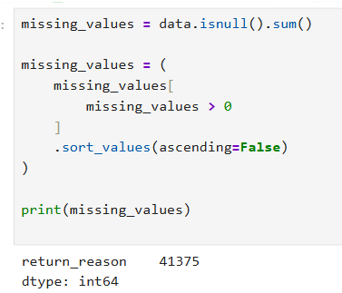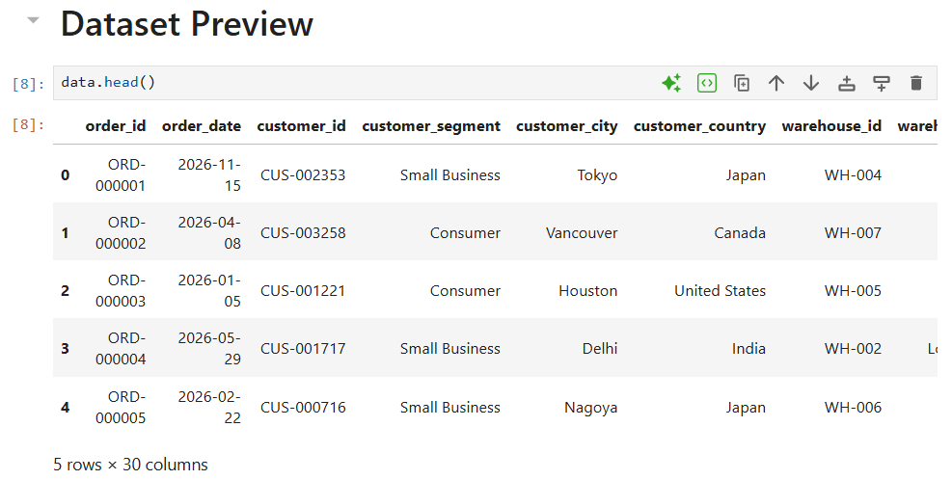
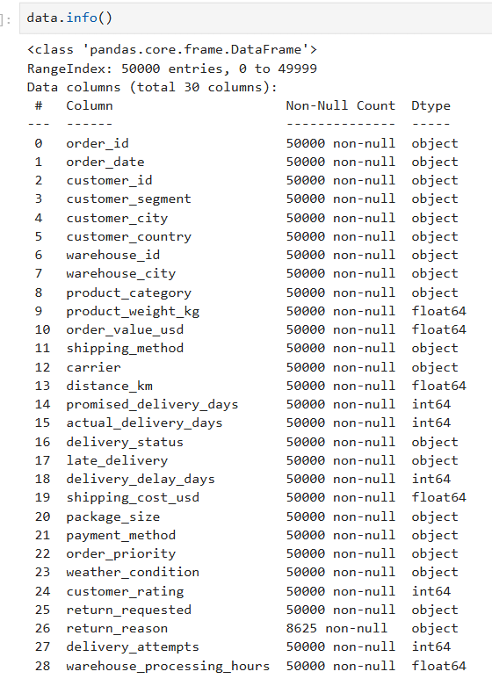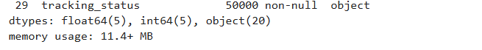
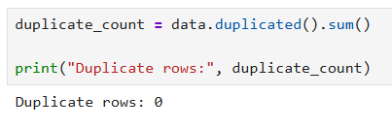

Exploratory Data Analysis (EDA)
EDA was performed to understand the distribution and relationships within the delivery and shipping data.
The analysis focused on:
- Order volume
- Delivery delays
- Shipping cost
- Delivery distance
- Order fulfillment
Relationship between distance and shipping cost
📊 Delivery Delay Distribution

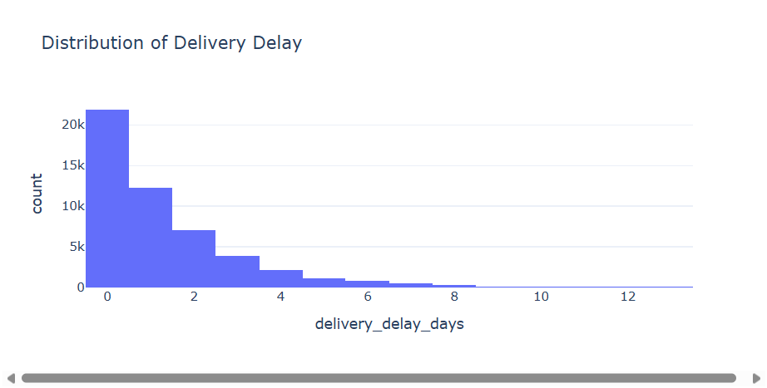
📊 Delevery Status Distibution
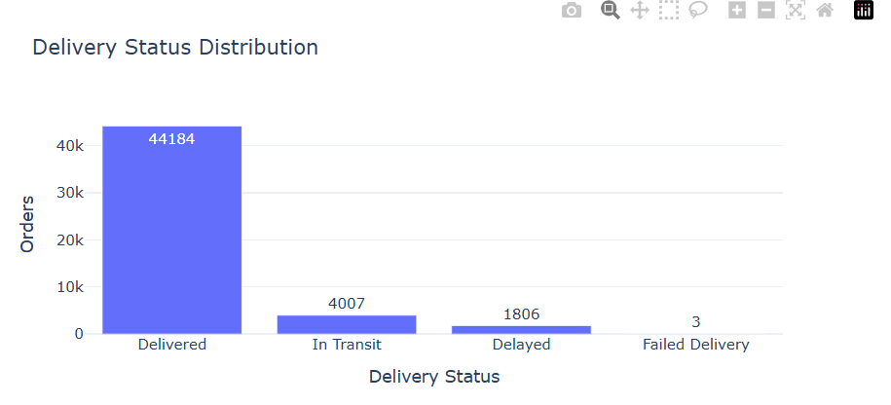 KPI Analysis
This table presents four key performance indicators (KPIs) that measure operational efficiency and customer satisfaction:
- Fulfillment Rate (88.37%) → Indicates how successfully customer orders are completed. A higher rate shows better reliability.
- Average Delay (1.28 days) → Represents the typical delay in order delivery. Lower values mean faster service.
- Average Shipping Cost (120.52) → Shows the average expense incurred per shipment. Helps track logistics efficiency and cost control.
- Average Customer Rating (3.37/5) → Reflects customer satisfaction and service quality. Higher ratings indicate better customer experience.

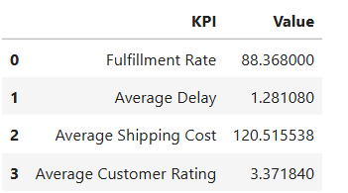

10. Delivery Delay Target Analysis
To evaluate logistics performance under different delivery delay constraints, an optimization scenario analysis was performed. Orders were filtered based on the maximum acceptable delivery delay.

1-Day Delay Delivery Target
- Orders : 34,084
- Average Shipping Cost: $ 98.49
- Average Distance: 2086.45
2-Day Delay Delivery Target
- Orders : 41,161
- Average Shipping Cost: $106.29
- Average Distance: 2253.89
3-Day Delay Delivery Target
- Orders : 45,045
- Average Shipping Cost: $111.33
- Average Distance: 2355.23

Comparison Table:
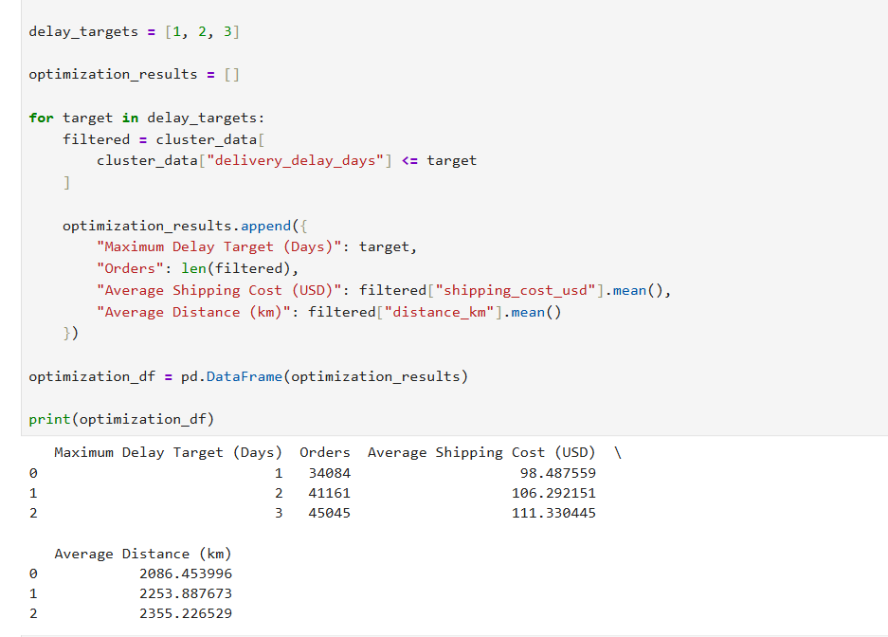

Key Findings
- The overall fulfillment rate is high at 88.37%, indicating strong delivery performance.
- Average delivery delay is only 1.28 days, showing relatively efficient logistics operations.
- The average shipping cost is $120.52 per order.
- Customer satisfaction is moderate with an average rating of 3.37/5.
- Longer delivery distances are associated with higher shipping costs.
- Relaxing delivery targets from 1 day to 3 days significantly increases the number of fulfilled orders.
- Regression can be used to predict shipping cost based on distance.
- Clustering can identify different delivery segments for targeted logistics strategies.

Distance Analysis
Delivery Distance Analysis
Delivery distance is an important logistics factor because longer distances may require additional transportation time and resources.
The analysis examines the relationship between delivery distance and shipping cost.
Business interpretation:
Understanding this relationship can help the organization:
Improve route planning.
Estimate shipping costs.
Identify expensive delivery routes.
Improve logistics planning.
Support pricing decisions.

Regression
Regression Analysis
Regression can be used to understand the relationship between numerical variables and predict future outcomes.
For this project, regression can potentially be used to predict:
Shipping Cost based on Delivery Distance
Conceptually:
Shipping Cost = f(Distance)
Simple explanation:
If delivery distance increases, shipping cost may also change. Regression helps quantify this relationship and can be used for cost prediction.
Future application:
The company could use a regression model to estimate expected shipping cost before dispatching an order.

Clustering
Clustering Analysis
Clustering is an unsupervised machine learning technique used to group similar observations.
For logistics data, orders can potentially be grouped using variables such as:
Delivery distance
Shipping cost
Delivery delay
Order characteristics
For example, orders may form groups such as:
Cluster 1: Short-distance, low-cost deliveries
Cluster 2: Medium-distance deliveries
Cluster 3: Long-distance, high-cost deliveries
These clusters can help the company design different logistics strategies.

Optimization:
Logistics Optimization
Optimization can be used to identify the best operational decision under given constraints.
In this project, optimization could be applied to:
Delivery route selection
Shipping cost minimization
Delivery time minimization
Vehicle allocation
Warehouse-to-customer assignment
Example:
The objective could be:
Minimize total shipping cost while maintaining the required delivery time.
Subject to constraints such as:
Maximum delivery capacity
Maximum acceptable delivery time
Available vehicles
Distance
Operational resources

Roadmap
- Data Collection
- Data Preprocessing
- Exploratory Data Analysis (EDA)
- KPI Analysis
- Distance & Shipping Cost Analysis
- Statistical Analysis
- Regression (Proposed Future Application)
- Clustering (Proposed Future Application)
- Logistics Optimization (Proposed Future Application)
- Business Recommendations & Conclusion
.
Libraries:
- Pandas
- NumPy
- Matplotlib / Plotly
- Scikit-learn
- Jupyter Notebook
Basic workflow:
- Key Findings
- Delivery target has a direct impact on the number of orders that can be fulfilled within the target period.
- Shipping cost is an important operational metric.
- Delivery distance is an important factor in logistics planning.
- Strict delivery targets require better operational coordination.
- Regression can support shipping-cost prediction.
- Clustering can identify different types of delivery patterns.
- Optimization can support cost and route management.

Recommendations
Business Recommendations
Based on the analysis, the following data-driven approaches can be considered:
Monitor delivery delay regularly.
Track average shipping cost as a key KPI.
Analyze high-distance delivery routes.
Use predictive models for shipping cost estimation.
Use clustering to identify different delivery segments.
Apply route optimization techniques.
Develop a real-time logistics dashboard.
Continuously monitor delivery performance.

Conclusion
The project demonstrates how data analytics can be applied to e-commerce delivery and shipping operations. By analyzing delivery delays, order fulfillment, shipping costs and delivery distances, organizations can gain better visibility into their logistics performance.
The analysis provides a foundation for developing more advanced predictive and optimization solutions. Regression can be used for shipping cost prediction, clustering can help identify similar delivery patterns, and optimization techniques can support efficient route and resource planning.
Overall, the project demonstrates the importance of combining business understanding, data analysis and machine learning techniques to support data-driven logistics planning.

Github URl

Appendix:
Python Code Illustration

import pandas as pd
import numpy as np

import plotly.express as px
import plotly.graph_objects as go

from sklearn.model_selection import train_test_split
from sklearn.compose import ColumnTransformer
from sklearn.pipeline import Pipeline

from sklearn.preprocessing import (
OneHotEncoder,
StandardScaler
)

from sklearn.impute import SimpleImputer

from sklearn.ensemble import RandomForestRegressor

from sklearn.cluster import KMeans

from sklearn.metrics import (
mean_absolute_error,
r2_score
)

Data Loading
data = pd.read_csv("C:/Users/HP/Downloads/E-commerce_Delivery_Shipping_Data_2026.csv")

Dataset Preview
data.head()
data.column
data.tail()

dataset information
data.info()
print("number of rows:",data.shape[0])
print("number of columns:",data.shape[1])

missing values

missing_values = data.isnull().sum()

missing_values = (
missing_values[
missing_values > 0
]
.sort_values(ascending=False)
)

print(missing_values)

Duplicate check

duplicate_count = data.duplicated().sum()

print("Duplicate rows:", duplicate_count)

KPIs
fulfillment_rate = (
data["delivery_status"]
.eq("Delivered")
.mean() * 100
)

avg_delay = data["delivery_delay_days"].mean()

avg_shipping_cost = data["shipping_cost_usd"].mean()

avg_rating = data["customer_rating"].mean()

print(f"Fulfillment Rate: {fulfillment_rate:.2f}%")
print(f"Average Delivery Delay: {avg_delay:.2f} days")
print(f"Average Shipping Cost: ${avg_shipping_cost:.2f}")
print(f"Average Customer Rating: {avg_rating:.2f}/5")

